(Approx. 735 words)

QR Codes: What They Are and How to Use Them
By Dorothy Fitch, Editor, GVR Computer Club, AZ
February 2021 issue, Green Bytes
https://www.ccgvaz.org/
dmfitch (at) cox.net

QR codes are popping up more and more frequently these days, and I began to wonder what they were all about. So, I did some investigating and tried creating and using them. It was a lot easier than I had expected and rather entertaining.
What is a QR code? Like barcodes on items at supermarkets, a QR code (short for Quick Response) is a two-dimensional way to store a lot of information. Known as a matrix barcode, the QR code was first designed in 1994 in Japan by Denso Wave, a subsidiary of Toyota Motor Corporation. Its goal was to "increase the efficiency in product tracking, item identification, time tracking, document management, and general marketing.... Because a QR code carries information in both vertical and horizontal directions, it can store several hundred times the amount of data carried by a bar code. In fact, over 7,000 numeric characters can be encoded in one QR code." Read more.
The QC code's design was inspired by Go, an ancient Japanese strategy game that uses black and white stones in a grid. Masahiro Hawa, the person assigned to develop a solution for Denso Wave, had his "aha" breakthrough while playing Go during a lunch break. This led to the invention of the QR code.
Go board with black and white stones that are placed on a grid.
(image from commons.wikimedia.org, a great source for free photos)
A QR code can link to a website, share contact information, send a text message, make a phone call, open a restaurant menu, allow you to check in for an appointment, play a video, and much more.
I created QR codes to link to specific websites that would be difficult to enter on a phone. By scanning the QR codes, you can immediately open up the web page. Try them out!
How to scan a QR code:
On an iPhone, use the built-in camera, which can automatically read QR codes. Read 'Scan a QR Code with your iPhone, iPad, iPod touch' at Apple Support.
On an Android phone, there are several ways to scan a QR code, depending on your specific model. There are many free apps available in the Google Play store that can scan QR codes, but you may not need one. The camera in newer versions of Android (10 and up) can scan them automatically. Try this to check: point the camera at a QR code and hold for a few seconds. If the camera doesn't scan it, long-press the Home button, then press the Google Lens icon (shown below), just to the left of the microphone icon at the bottom of the screen. Tap the shutter button to search for its meaning. You should see the URL for the website and link directly to it. I also found I could easily use a free QR code scanner without installing the app. Swipe down from the top of the phone and click the Search (question mark) icon to get to the Finder Search. Type QR, then locate and click the QR Scanner icon. Once it scans the code, press OPEN to follow the link. Read more about how to scan QR codes on an Android phone.
Google Lens icon, referenced above
How to create a QR code:
I created the QR codes using this free website: goqr.me. All I had to do was type in the web address I wanted the code to take me to; it automatically generated the QR code, which I could then download. Try scanning these QR codes and see where they take you.
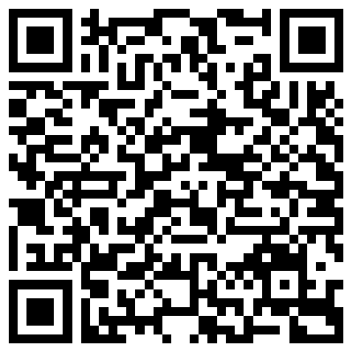 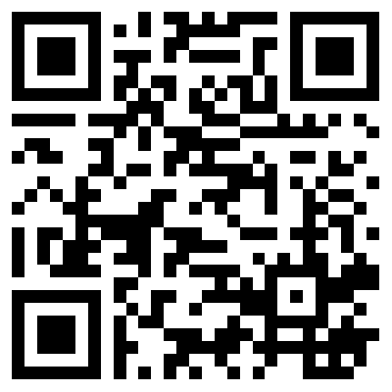
What's special about February 8? Read a good classic book!
In addition to using QR codes to link to websites, you can also create ones that store text: not SMS text messages, but plain text, as in a birthday message or poem.
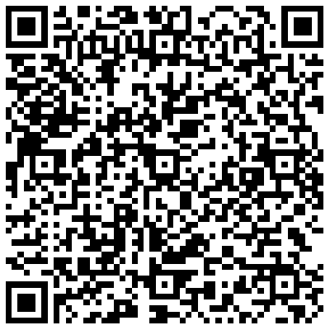
Can you read this fun limerick?
I've cheated a bit in this article. For those who prefer not to attempt to scan the QR codes, you can just click each image to access its content. Usually, QR codes are printed and you couldn't do that!

Here's a challenge for you, though: create a QR code and email it to a teenager. They will think you are so cool, knowing about QR codes!

